Introduction: Time Attendance Device Data including: Attendance Records and User Data

**I : Syn User Data between different Time Attendance Devices**

Transfer the User Data from one Time Attendance Devices to another Time Attendance Device, then we can punch for attendance from both of these two Time Attendance Device.

Following is to introduce how to syn User Data from multi Time Attendance Devices in BS API.

1. first of all, Time Attendance Device login to the Cloud System, it would report its own Serial Number, the Cloud System will assign several Devices to one Group.

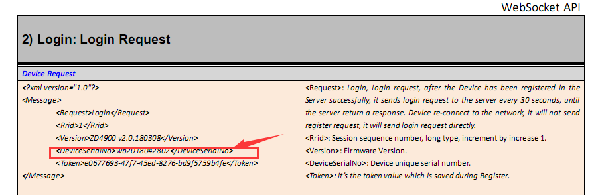

2. assign ID and name to all the users (not including the Fingerprint , Face Template). To form a list. And send all the user data from this list to all the Time Attendance Devices that in this Group by the command SetUserData.

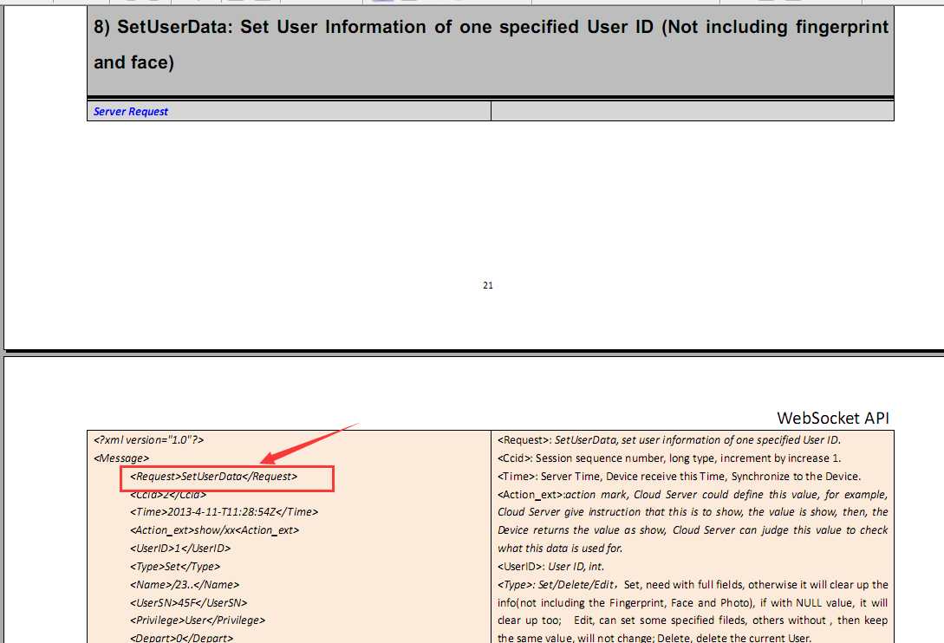

NOTE: <Enabled>Yes/No</Enabled> this is to set if the User is resign or not, Set as “No”, means user is on resign status, User Data is not deleted, but this user cannot punch for attendance record any more.

3. User enroll the Face Template / Fingerprint Template / ID card, from any one of the Time Attendance Device from the Group, this Device will send a command AdminLog automatically to tell you from which Time Attendance Device and what has been enrolled.

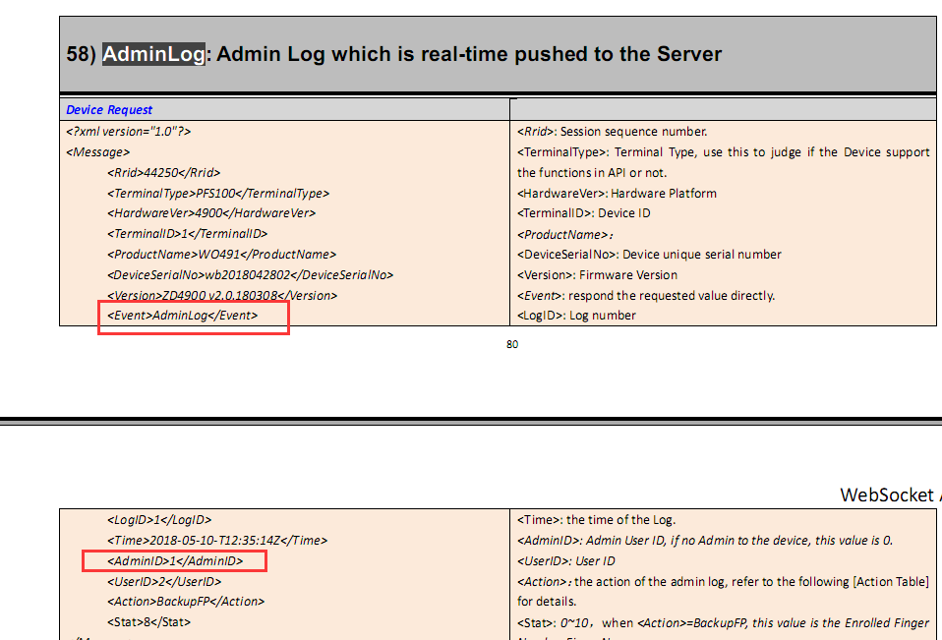

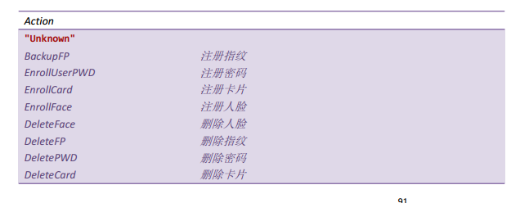

4. from the Time Attendance Device which the Server received the AdminLog, Get the User Fingerprint Template / Face Template / ID card Number by command GetUserCardNo, GetFingerData, GetFaceData and save the data.

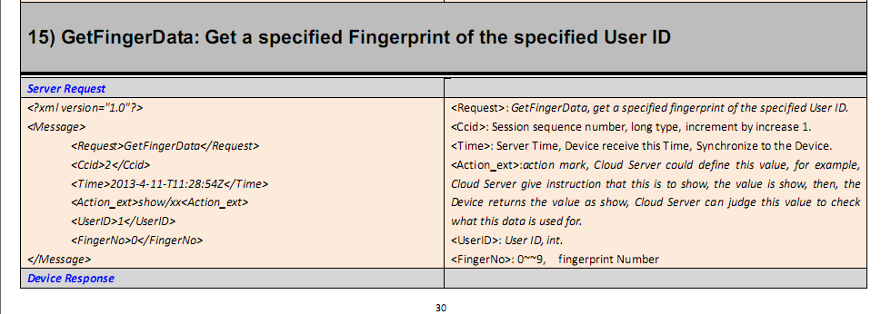

5. Send the data which we received just now to other Time Attendance Devices which is in the same Group via the command SetUserData, SetFingerData, SetFaceData.

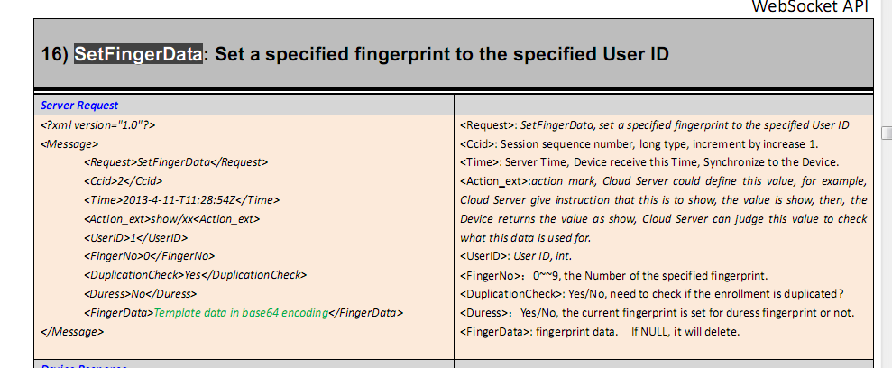

6. The user can punch for attendance in any of the Time Attendance which is in the same Group now.

NOTE:

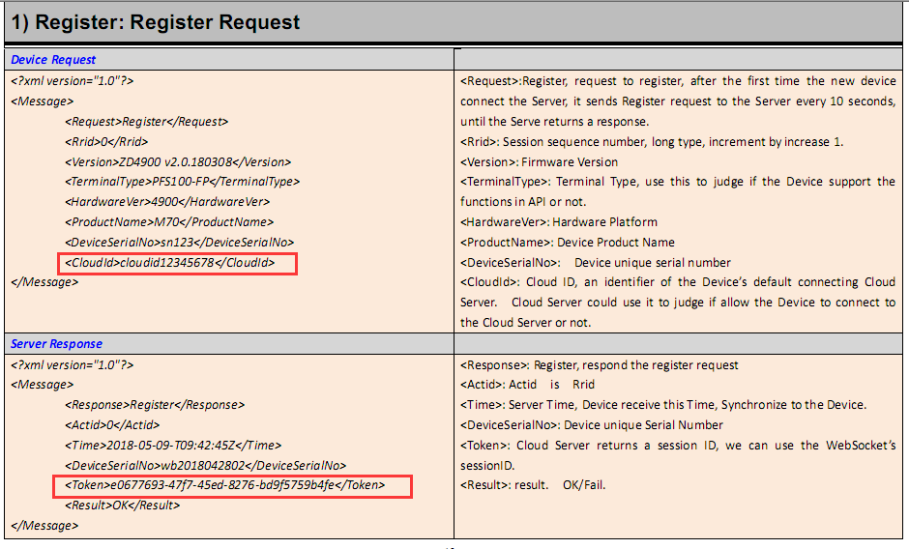

Register command will be send to the Server for one time, use the CloudID to judge if it is your device. Cloud System reply the Token value, this token value will be saved in the Time Attendance Device, and in future, this Device connect to the Cloud System, it will skip this register step, and direct login, and upload the token value. If Restore the device to factory settings, the Device will re-send the register command.

**II: Get Attendance Records**

Each time when the user punch successfully on the Time Attendance Device, the Device will automatically send a TimeLog, including the User information, after generate could form a report.

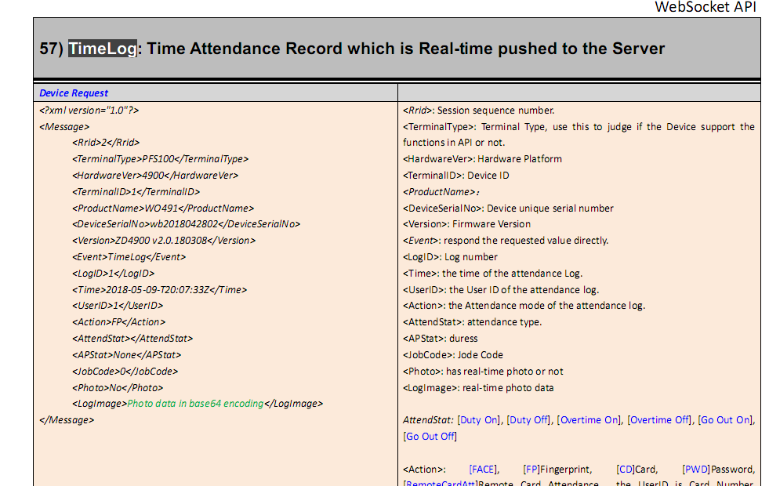

NOTE: TimeLog and AdminLog, the Server must reply correctly, otherwise, the Device will repeat sending, until get the correct respond from the Server. For the <Actid> value of Reply must be same as the <Rrid> value from Request.

Rrid is the sequence number of the Device request, Ccid is the sequence number of the Server request, Actid is the sequence number of Reply. Rrid(device)=Actid(server);Ccid(server)= Actid(device).